2021 ☐ 2022 ☐ 2023 ☐ 2024 ☐
2021 OFFICIAL MEMBERSHIP APPLICATION
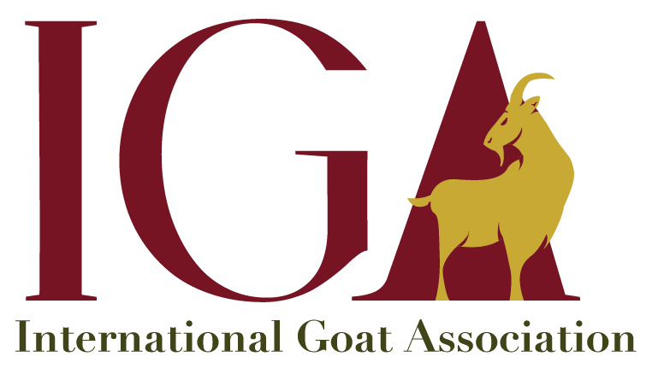
Membership year
(Check applicable box or boxes)

Family name: Tap here to enter text. | Given or First Name: Tap here to enter text.

Title: Tap here to enter text. | Organization: Tap here to enter text.

Address: Tap here to enter text.

City/State: Tap here to enter text. | Country/Zip Code: Tap here to enter text.

Telephone Number: Tap here to enter text. | Fax Number: Tap here to enter text.

Email: Tap here to enter text.

IGA Memberships
Standard IGA Memberships for countries above .500 on the UN-Human Development Index
☐ $55.00 USD per year – one-year IGA membership* without the hardcopy journal
☐ $155.00 USD per year – one-year membership* with the official hardcopy journal, Small Ruminant Research
☐ $37.50 USD per year – one-year student membership *
☐ $10.00 USD per year – one-year student membership without access to Small Ruminant Research **
☐ $200.00 USD (one-time payment) – lifetime membership (for those 60 years of age and older)

UN-Human Development Index countries below .500
☐ $30.00 USD per year – one-year IGA membership* without the journal
☐ $70.00 USD per year – one-year IGA membership*, including Small Ruminant Research
* includes online access to Small Ruminant Research and is valid for 1-year from the date payment is received
** submit proof of school enrollment

payment option: ☐ Credit Card ☐ Check ☐ Cash ☐ Wire Transfer
$ 00.00

Total amount enclosed (check) or to charge to credit card (Visa or MasterCard):

Credit Card Number (all digits)  xxxx xxxx xxxx xxxx | Expiration Date  month/year  mm / yy | Security code  xxx

Signature: Tap here to enter text. | Date: Tap here to enter text.

